Solar UPS Project

Prepared by

Refik Erkan Günhan

B1405.010023

January 2019

ABSTRACT

In today’s World with the increased air temperature, people’s quality of life is highly affected in a negative way. As we all know that global warming is a real issue and it can’t be ignored. However so many people and World countries ignore that problem and still use non- renewable energy sources. If we look at the researches we can see that renewable energy is only used in the World by %5. Due to this number, people’s life is higly affected and the air temperature is increasing year by year.

So the aim of my project is to make people realise that problem and hopefully maket hem use more renewable energy sources. In my project I am using solar energy which is a renewable energy source to charge the 12V battery with a solar panel. Solar UPS project then converts the batteries 12V DC to 220V AC to provide enough current for the machine or whatever we plug in inverter. As I mentioned I used an inverter to change the voltage which is the first circuit of this project but the project in total consist two circuit in it. The other circuit that I am using is solar charge controller circuit. With the solar charge controller I can see that if the battery is charging or not with the help of arduino.

I also used arduino to connect all the pieces of the circuits and coded the arduino chip with the arduino software. With the help of the arduino software I tested my project if it is working properely or not and coded the circuits as a need to.

By following these steps, I completed the project and connected all the pieces of the two circuit and created Solar UPS Project with the help of arduino and I hope that this project will increase the amount of usage in renewable energy source like solar energy.

Contents of Project

1 Chapter 1: Introduction ....................................................................................................... 8

1.1 Background ………………………………………………………………………………………………………………. 8

1.2 Project Motivation ……………………………………………………………………………………………………. 8

1.3 Problem Statement …………………………………………………………………………………………………… 8

1.4 Project Question ……………………………………………………………………………………………………….. 9

1.5 Project Objectives …………………………………………………………………………………………………….. 9

1.6 Project Significance …………………………………………………………………………………………………... 9

1.7 Project Scope ……………………………………………………………………………………………………………. 9

1.8 First Steps …………………………………………………………………………………………………………………. 10

2 Chapter 2:Literatur Review …………………………………………………………………………………………….. 12

2.1 Solar Ups Project ……………………………………………………………………………………………………….. 12

2.2 Definition Of Solar Ups Project ………………………………………………………………………………….. 12

2.3 Using Arduino ……………………………………………………………………………………………………………. 12

2.4 Why Arduino ……………………………………………………………………………………………………………… 14

2.5 Inverter …………………………………………………………………………………………………………………….. 15

2.6 Solar Panel ………………………………………………………………………………………………………………… 15

2.7 Relate Work ………………………………………………………………………………………………………………. 17

2.8 Solar Charge Controller ……………………………………………………………………………………………... 17

2.9 Inverter Circuit …………………………………………………………………………………………………………. 18

3 Chapter 3:Project Methodology …………………………………………………………………………………….. 21

3.1 Adopted Methodology ………………………………………………………………………………………………. 21

3.2 Waterfall Methodology …………………………………………………………………………………………….. 22

3.3 Why Adopting Waterfall Is Suitable For Solar Ups …………………………………………………….. 22

3.4 Implementation Of Waterfall ……………………………………………………………………………………. 22

4 Chapter 4:Analysis And Design ………………………………………………………………………………………. 25

4.1 Project Description ……………………………………………………………………………………………………. 25

4.2 User Description ……………………………………………………………………………………………………….. 25

4.3 Requirements Development …………………………………………………………………………………… 25

4.4 System Requirements ……………………………………………………………………………………………… 25

4.5 Functional Requirements ………………………………………………………………………………………… 26

4.6 User Requirements ………………………………………………………………………………………………….. 26

4.7 Non-Functional Requirements …………………………………………………………………………………. 26

4.8 System Analysis ……………………………………………………………………………………………………….. 28

4.9 Use-case Diagram …………………………………………………………………………………………………….. 28

4.10 Block Diagram ………………………………………………………………………………………………………… 29

5 Chapter 5:Implementation ……………………………………………………………………………………………. 31

5.1 Design Phase ……………………………………………………………………………………………………………. 31

5.2 Building The Hardware …………………………………………………………………………………………….. 32

5.3 Building The Software ………………………………………………………………………………………………. 33

5.4 Implementation Phase ……………………………………………………………………………………………… 33

5.5 Real Design Of The Project ………………………………………………………………………………………… 34

6 Chapter 6:Testing And Tools ………………………………………………………………………………………….. 40

6.1 Testing ………………………………………………………………………………………………………………………. 40

6.2 Performance Testing …………………………………………………………………………………………………. 40

6.3 Functionality Testing …………………………………………………………………………………………………. 40

6.4 Tools And Techniques ……………………………………………………………………………………………….. 42

6.5 Maintance …………………………………………………………………………………………………………………. 43

6.6 Conclusion …………………………………………………………………………………………………………………. 43

References ………………………………………………………………………………………………………………………… 44

List of Tables

2 Table Similar Project Comparisson …………………………………………………………………………………. 19

5 Table Hardware Tools …………………………………………………………………………………………………….. 32

6 Table Tools And Techniques …………………………………………………………………………………………… 42

List of Figures

2 Figure Arduino Uno Chip ………………………………………………………………………………………………… 13

2 Figure Solar Panel …………………………………………………………………………………………………………… 16

2 Figure Solar Charge Controller Circuit …………………………………………………………………………….. 17

2 Figure Inverter Circuit ……………………………………………………………………………………………………. 18

3 Figure Waterfall Methodology ……………………………………………………………………………………….. 21

3 Figure Waterfall Steps ……………………………………………………………………………………………………. 23

4 Figure Non-Functional Requirements …………………………………………………………………………….. 27

4 Figure Use-Case Diagram ……………………………………………………………………………………………….. 28

4 Figure Block Diagram ……………………………………………………………………………………………………… 29

5 Figure System Structure …………………………………………………………………………………………………. 31

5 Figure Real Designs Of The Project …………………………………………………………………………………. 34



**CHAPTER 1: INTRODUCTION**



1 CHAPTER 1: INTRODUCTION

In today’s World global warming is an ongoing and increasing problem. Due to global warming World’s climate increases year by year and to the researches World will suffer 0.5 celsius degree increase just in twelve years. This might not seem that much to people however it is a big problem for the environment especially for South and North pole of the World. Because of the fact of glacier melting the level of the seas are increasing every year.

This is becoming a major problem to the seaside countries. So how are we going to stop or stabilize this problem? We can use renewable energy sources like solar energy, wind energy and so on. However World energy usage due to a research done in 2016 is like this and it is not looking good for us which is 80% fossil fuels, 10% biofuels, 5% nuclear and 5% renewable energy. So we can increase the percentage of renewable energy using more solar power which is the main factor of my project.

* 1. BACKGROUND

Solar power is very unique and the most important renewable energy source. We can use solar energy to create electrity with the usage of solar panels. We can use it to cahrge our phone batteries, for the traffic lights and almost anything we can imagine. For this project I will use the solar energy to charge my ups with using arduino circuits. It will be combined Project of two circuits of arduino. One of the circuit will be an inverter circuit to take the DC power and convert it to AC power. By doing that the inverter will convert 12V DC signal to a single phase around 220V AC. The other circuit is a solar charge controller circuit. A solar charge controllers main purpose is to manage the solar power from the sun with a solar panel and charge the batterry with that solar energy. These two circuits combined creates solar UPS Project. So the purpose in that is to charge the DC battery with the help of the solar panel and then that batterry is used to power the AC load using inverter. As I explained the inverter 12V DC to 220V AC thus the circuit now provide a AC load. So the main circuit now can continuously charge the battery with solar panel and inverter changes the DC load to a AC load succesfully. By that main circuit now can be used as a UPS in case of emergency power cuts.

* 1. PROJECT MOTIVATION

This Project stands for using the solar energy and charge a DC batterry with it and changes that DC load to a AC load using inverter. The usage of the solar energy to charge the DC batterry is the main thing that motivated me to make this Project because of the fact global warming and in emergency power cuts this Project can be used as a UPS.These are the two main things that motivated me to chose and make this Project.

* 1. PROBLEM STATEMENT

As long as the global warming continues and the weather of the world keeps increasing, people need to use more renewable energy sources instead of non-renewable energy source. According to this statement people must slowly adjust theirselves to using renewable sources before it is too late for the world.

* 1. PROJECT QUESTION

The focus questions of developing a solar ups are:

* How to convert DC load to AC?
* How to convert solar energy to electric energy?
* How to combine inverter circuit with solar charge controller circuit?
* How to use the main circuit as a UPS?
  1. PROJECT OBJECTIVES

The main objectives of this Project can be listed by these:

* Succesfully converting DC load to AC using solar energy.
* Combining inverter circuit with solar controller circuit.
* Using the main circuit as a UPS.
* Using a renwable energy souce instead of a non-renewable energy source.
* Helping people get used to using more renwable energy source based things instead of non-renawable energy source.
* Helping the World maintain its temperature as stable as possible.
* Evaluate the hardware part of the project with the software part.
  1. PROJECT SIGNIFICANCE

This projects significance is very critical due to the lack usage of renewable energy souces. This prject aims to change that at least a bit fort he environment. This project signifance alsa cam be listed by these matters:

* Linking software with hardware.
* Using the project as UPS in case of emergency power cuts.
* Using solar power for a renewable energy source.
* Combining two seperate circuit and making them one.
* Awekening the awerness of people in concept of global warming.
  1. PROJECT SCOPE

The scope of this project is for all people. This project aims people to understand global warming is a dead serious issue that can kill lots of human being if we do nothing. So with this project I want to increase the number of usage in renewable energy sources like solar power because the usage of renewable energy source is now just 5% in the whole globe. So I want to increase the number with this project as an alternative UPS which works with a renewable energy source compared to other UPS devices.

* 1. FIRST STEPS

At first I tried to built a inverter circuit and solar charge controller circuit seperately. After I started building inverter circuit I realized that it is not safe one person to work on this circuit due to the fact that it is a high voltage circuit. So I consulted some of my friends and decided to buy an ready inverter and started building solar charge controller circuit. I bought the necessary equipment for building the solar charge controller and started my project. The only thing remained was the solar panel. After I found the solar panel I stopped working on hardware part because I managed in my head to create the hardware part of this project and started working on the software part of the project.

Working on the software part was a little bit more difficult for me because at first I didn’t know how to write code on arduino. So I decided to do some researches from the internet to learn how to handle the software part of the project. After my researches I found that the software part is not as difficult as I imagined in my head. So I decided to complete the sofware part of the firstly and then test the code on the hardware part of the project when it is done.



**Chapter 2: LıTERATURE REVIEW**



1. CHAPTER 2: LITERATURE REVIEW

This chapter includes a literature review of Solar UPS project,concepts and benefits for users.

* 1. SOLAR UPS PROJECT

Solar UPS Project is divided into three main phases: Building the software part of the project to maket he project works as a UPS and the hardware part of the project which are cointainig two seperate circuits and getting everything done about hardware part.

* 1. DEFINITION OF SOLAR UPS PROJECT

It is a circuit consiting of two main circuits which has a solar panel to take solar energy and use it to charge the battery. With this way the circuit will wokr as a UPS and contunie working when there is cuts in power.

* 1. USING ARDUINO

To use arduino we must first understand how to use arduino and what is arduino. So what is exactly arduino? Arduino is an open source electronics platform based on easy to use hardware and software.[Arduino boards](https://www.arduino.cc/en/Main/Products) are able to read inputs light on a sensor, a finger on a button or a message and turn it into an output - activating a motor, turning on an LED, publishing something online. You can code your board what to do by sending a set of instructions to the microcontroller on the arduino board. To do so you use the [arduino programming language](https://www.arduino.cc/en/Reference/HomePage) (based on [Wiring](http://wiring.org.co/" \t "_blank)), and [the Arduino Software (IDE)](https://www.arduino.cc/en/Main/Software), based on [processing](https://processing.org/" \t "_blank).

Over the years Arduino has been the main source of thousands of projects, from daily use items to complex scientific instruments. A worldwide community of creators, programmers, hobbyists, artists, students and professionals has gathered around this open source platform, their contributions have added up to an incredible amount of [accessible knowledge](http://forum.arduino.cc/) that can be of great help to novices and experts alike.

Arduino was born at the Ivrea Interaction Design Institute as an easy tool for fast prototyping, aimed for students without a background in programming and electronics. As soon as it reached a wider community, the arduino board started changing to adapt to new challenges and needs, differentiating its offer from simple 8-bit boards to products for Internet of Things (IoT) applications, wearable, 3D printing, and embedded environments. All arduino boards are completely open-source, enabling users to build them independently and eventually adapt them to their particular needs.  The [software](https://www.arduino.cc/en/Main/Software) is also open source and it is growing through the contributions of users worldwide.

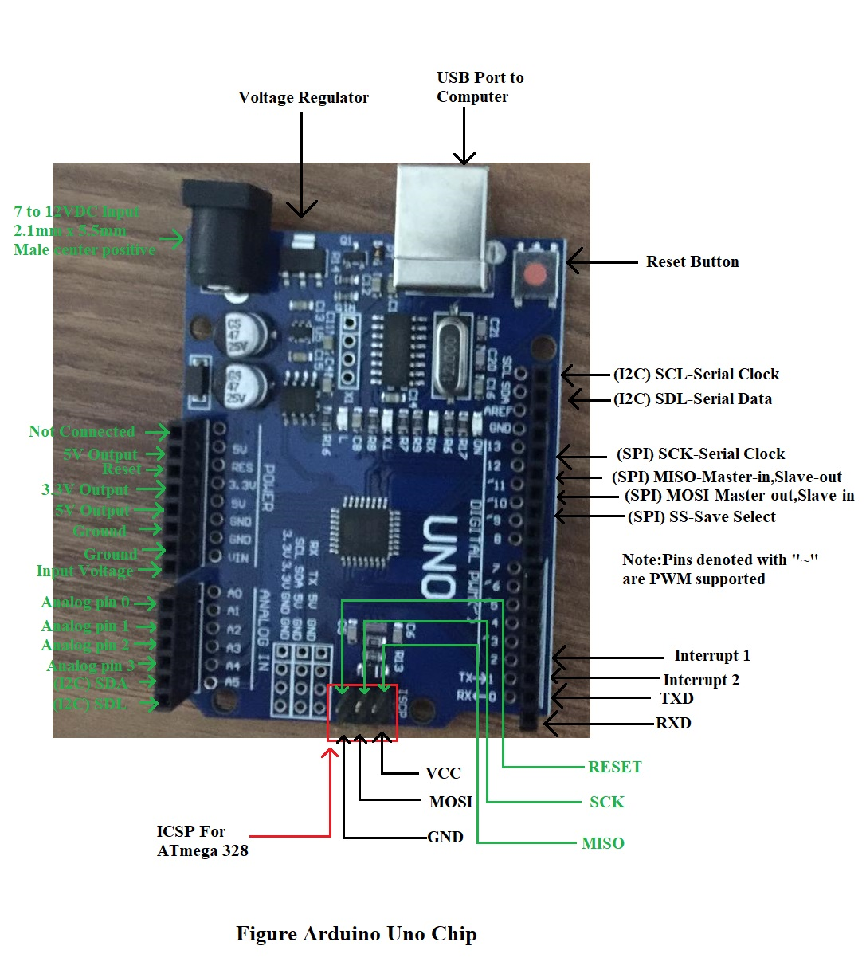

* 1. WHY ARDUINO

Thanks to arduino’s accessible and simple user experience, arduino has been used in thousands of different projects and applications. The arduino software is easy to use for beginners, yet flexible enough for advanced users.It runs on every operating system like Linux,Mac and Windows.Both students and teachers use it to build low cost scientific instruments to prove physics and chemistry principles or to get started with programming and robotics.Designers and architects build interactive prototypes, musicians and artists use it for installations and to experiment with new musical instruments.Makers use it to build many of the projects exhibited at the Maker Faire, for example.Arduino is a key instrument to learn new things.Anyone children, hobbyists, artists, programmers can start tinkering just following the step by step instructions of a kit or sharing ideas online with other members of the arduino community.

There are many other microcontrollers and microcontroller platforms available for physical computing. For example Netmedia's BX-24, Parallax Basic Stamp, MIT's Handyboard, Phidgets and many others offer similar functionality.All of these tools take the cluttered details of microcontroller programming and wrap it up in an easy to use package.Arduino also simplifies the process of working with microcontrollers, but it offers some advantage for users over other systems:

* **Inexpensive** - Arduino boards are relatively inexpensive compared to other microcontroller platforms. The least expensive version of the Arduino module can be assembled by hand, and even the pre assembled Arduino modules cost less than 50 liras.
* **Cross-Platform -** The Arduino Software (IDE) runs on all operating systems like Windows, Macintosh OSX, and Linux operating systems. Most microcontroller systems are limited to just Windows operating system.
* **Simple, Clear Programming Environment -** The Arduino Software (IDE) is easy to use for beginners, yet flexible enough for advanced users to take advantage of as well. For teachers, it's conveniently based on the Processing programming environment, so students learning to program in that environment will be familiar with how the Arduino IDE works.
* **Open Source and Extensible Software -** The Arduino software is published as open source tools, available for extension by experienced programmers. The language can be expanded through C++ libraries, and people wanting to understand the technical details can make the leap from Arduino to the AVR C programming language on which it's based. Similarly, you can add AVR-C code directly into your Arduino programs if you want to.
* **Open Source and Extensible Hardware -** he plans of the Arduino boards are published under a Creative Commons license, so experienced circuit designers can make their own version of the module, extending it and improving it. Even relatively inexperienced users can build the [breadboard version of the module](https://www.arduino.cc/en/Main/Standalone) in order to understand how it works and save money.
  1. INVERTER

Many different devices are used in order to save energy. In this sense, in order to save energy, the devices that regulate the frequency setting in the circuits are called the inverter. All devices that convert alternating current to direct current, direct current to alternating current, works with a 3-phase operation system and regulates voltage and frequencies are called inverters.

* 1. SOLAR PANEL

Solar panel is a unique panel that converts solar energy into electric energy for us to use at home or at workplaces. The solar panel manages that convertion with the cells on the solar panels and these cells start to generate direct current through the sun's rays. By measuring the amount of energy obtained according to the region or the season in which it is used, a series or parallel mechanism is established and connected to the house or workplace.

With its durable structures you solar panel provides us energy saving by using it for many years and it is very environment friendly. It does not pollute the environment and does not cause discomfort because it works silently. The main reason why it is preferred a lot nowadays is it provides high efficiency. Especially on sunny days, the yield is quite high. The solar panel has many other benefits when it comes to usage:

* It provides great convenience in the provision of electrical energy in areas where there is no electrical energy.
* It is a easy to establish product.
* There is no maintenance cost.
* It can be established on the roof, terrace or balconies of the houses.
* With its sloped structure, it ensures both the sun's rays to be taken better and the accumulation of snow and rain water on the winter.
* It works silently.
* It does not emit carbon monoxide, radiation, sulfur or smoke into the environment.
* Thanks to its advanced technological structure, it allows you to benefit from inexhaustible solar energy for many years.

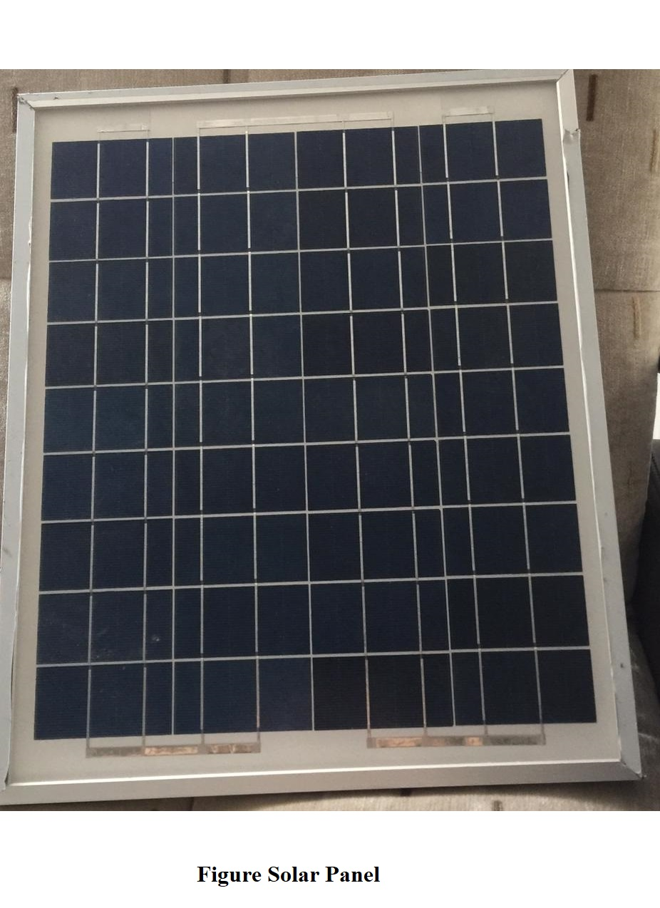

* 1. RELATE WORK

As I mentioned earlier there are similar projects which uses similar components to this project and actually this project is the combined of those two project.

* 1. SOLAR CHARGE CONTROLLER

A solar charge controller or charge regulator is a voltage and current regulator to keep batteries from overcharging. It regulates the voltage and current coming from the solar panels going to the battery.

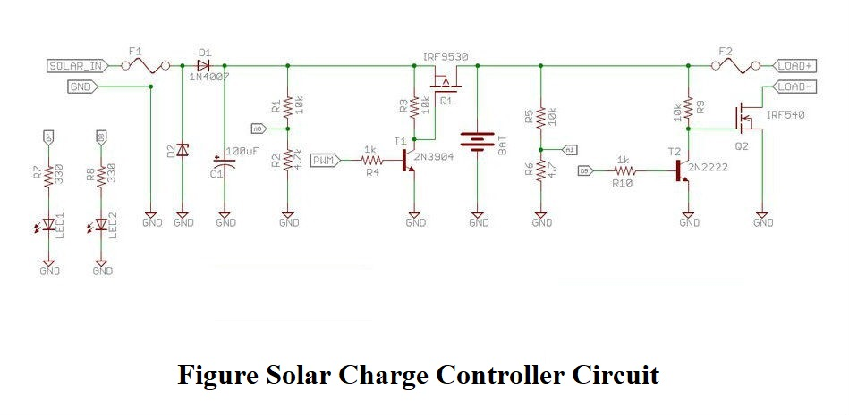

* 1. INVERTER CIRCUIT

As I aforementioned an inverter is a device which converts alternating current to direct current, direct current to alternating current. A basic inverter ciruit contains a control circuit, oscillator, switching devices, drive circuit for the power devices and a transformer.

The conversion of direct current to alternating current voltage is achieved by converting energy stored in the direct current source such as the battery into an alternating current voltage. This is done by switching devices which are continuously turned on and off, then stepping up using the transformer. You can see some examples which do not use a transformer. However these aren’t widely used.

The direct current input voltage is switched on and off by the power devices such as MOSFETs or power transistors and the pulses fed to the initial side of the transformer. The changing voltage in the primary induces an alternating voltage at secondary winding. The transformer also works as an amplifier where it increases the output voltage at a ratio determined by the turn’s ratio. In almost every cases the output voltage is raised from a 12V supply battery to 120V or 220V AC.

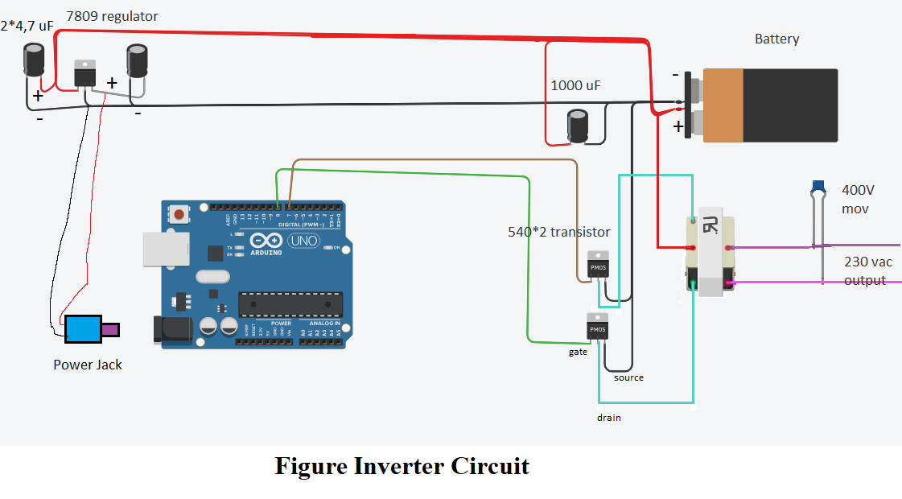

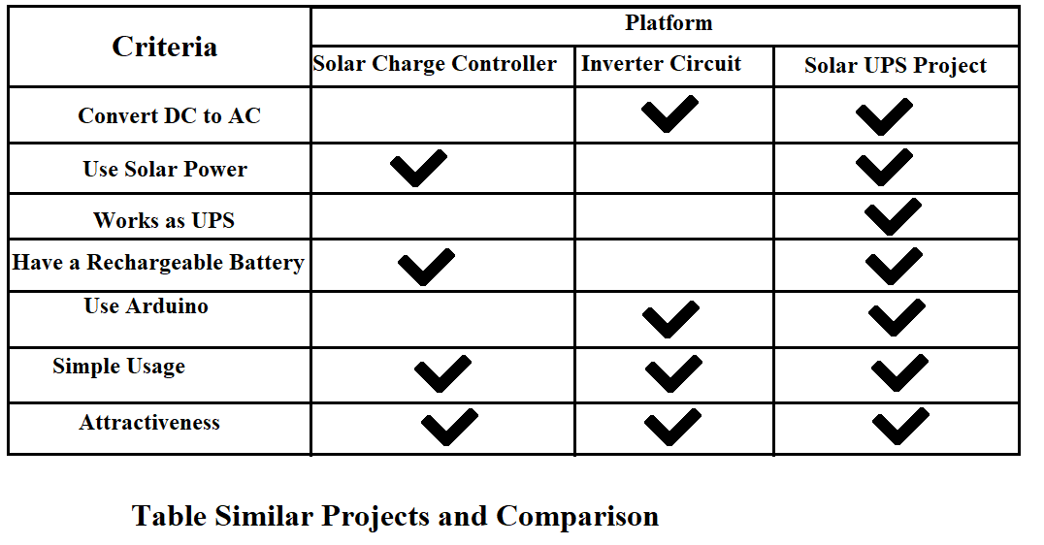



**Chapter 3: PROJECT METHODOLOGY**



1. CHAPTER 3: PROJECT METHODOLOGY

In this chapter I will describe the adopted methodology that I used in the project. I will describe the methodology phases that I will use to accomplish the project and the phases that the methodology consist.

* 1. ADOPTED METHODOLOGY

The adopted methodology during the development of this project is the waterfall methodology because it was the most suitable methodology for a project like Solar UPS. Also as I mentioned earlier, I understood the reqirements very well for this project. There are five steps in waterfall methodology starts with requirement analyses, followed by design, implementation, verification and finishes with testing and maintenance.

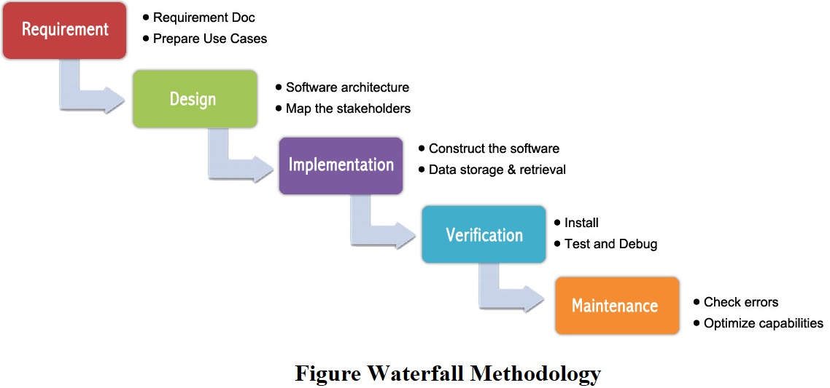

* 1. WATERFALL METHODOLOGY

The waterfall methodology was first introduced by Dr. Winston W. Royce in a paper published in 1970. The waterfall methodology emphasizes that a logical progression of steps be taken throughout the software development life cycle. It is now the most used methodology and it gets its name from the analogy of water falling downward. When the waterfall methodology was first introduced it was difficult for usage because it was incomplete in its

original framework and structure. Today, the most used version available includes a

corrective feedback mechanism.

* 1. WHY ADOPTING WATERFALL IS SUITABLE FOR SOLAR UPS ?

I adopted this methodology for the project because:

1. The requirements are clear, simple, and well understood for the project.
2. It can be developed step by step.
3. I understood the requirements of the project very well.
4. It was very suitable for this project.
   1. IMPLEMENTATION OF WATERFALL

The steps of the waterfall will be implemented to achieve this project. Each step has its own functions like in implementation and coding i will make the hardware design, processing design and software design.

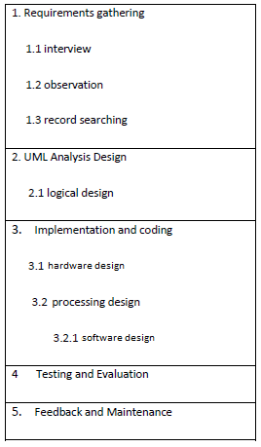

**Figure Waterfall Steps**



**CHAPTER 4: ANALYSIS AND DESIGN**



1. CHAPTER 4: ANALYSIS AND DESIGN

This chapter will provide a full description of the project and its users. Then this chapter will provide functional and non-functional requirements that have been collected using various methods. After the determination of the requirements, requirement analysis was adopted using various tools like use-case diagram, block diagram.

* 1. PROJECT DESCRIPTION

Solar UPS project is a combined project of two circuits. These two projects are solar charge controller circuit and inverter circuit. The purpose of the project is to charge a battery using a solar panel and then use it as a UPS in case of emergency power cuts. The project was developed more than two months.

At first the project was just a solar charge controller circuit so it was just controlling if the battery is charging with solar power. After that I managed to combine an inverter to the charge controller circuit. That way the project was nearly done. After applying the arduino chip to the project it was done.

* 1. USER DESCRIPTION

There is one main user fort he project. The user must put the Solar UPS project under the sun where the solar panel can get the lights of the sun. This has to be done in order to charge the battery.

User can customize the circuits model with the help of a top cover which protects the project. User can remove that cover easily and can work with the circuit as they like.

* 1. REQUIREMENTS DEVELOPMENT

To develop the functional and non-functional requirements of the project, I made a lot of researches from internet, talked with my friends and made brainstorming with them. With the help of my friends and the knowledge I got from my researches I generated the requirements according to the previous models I mentioned earlier.

* 1. SYSTEM REQUIREMENTS

Before the creation of the project, it is a must to anticipate the model and design of the project. How the user will intereact with the circuit. After thinking these in mind we can get the necessary requirements for the project. These requirements will determine the quality and chracteristic of the project to make a easy usage for users. After the reqirements are ready we can develop other technical works like system design, development of the project, testing, implemantation and operation.

Like in every system there are functional and non-functional reqirements to be considered to determine the reqirements of the project. With the non-functional requirements we can describe how the system work like reliability and maintainability.

* 1. FUNCTIONAL REQUIREMENTS

The functional requirements were developed by reviewing literature review, comparing similar circuits, interviewing and brainstorming with friends and experts.

The user who will use this project will have specific requirements in order to use this project.

* 1. USER REQUIREMENTS

The main requirement for this project is the solar power which comes from the sun for the user to use the circuit properly.

1. User should put the circuit under the sun in order to charge the battery.
2. User must open the inverter in order to get enough electric power from the circuit.
3. User should have a laptop or pc and Arduino IDE software downloaded on that laptop or pc in order to see that the battery is charging or not.
   1. NON-FUNCTIONAL REQUIREMENTS

So many non-functional requirements can be considered in order to develop this project. For example, the circuit must be simple to achieve its goal, it must be understandable, easy to learn and use. To make that happen I brainstormed with a lot people mostly my friends who have more knowledge than me in this particular subject and adopted non-functional requirements to the circuits.

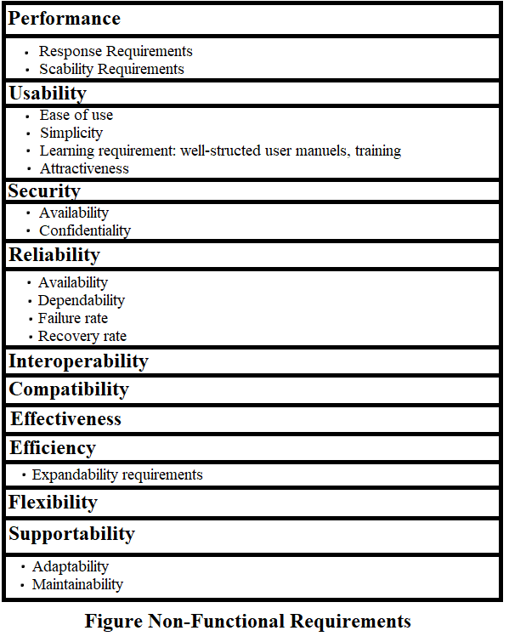

* 1. SYSTEM ANALYSIS

This section will contain the analysis of funtional and non-functional requirements of the project using use-case diagram and activities will be analized using a block diagram.

* 1. USE-CASE DIAGRAM

To see the main aspects of the project I developed a use-case diagram. The diagram shows the interaction between the user and the system. The use-case diagram was developed in order to clarify, identify and organize system requirements.

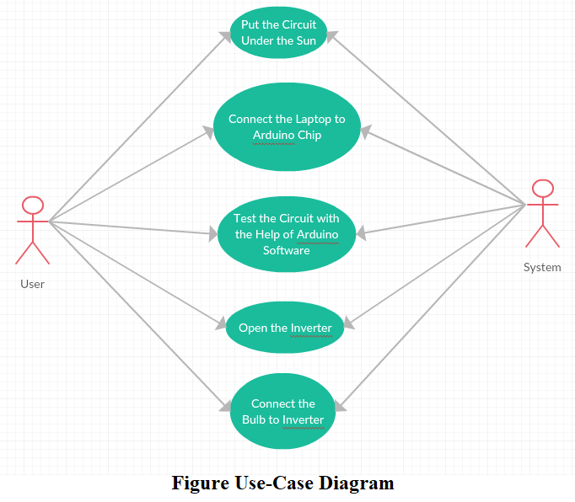

* 1. BLOCK DIAGRAM

To see the systems main circuit I developed a block diagram. The whole systems controlling device is the Arduino UNO microcontroller. The inverter, solar panel, charge controller, relay module are all connected to the Arduino UNO microcontroller. The controller acts according to the solar power. If we put the solar panel under the sun the controller will circuit will charge the battery with the software of microcontroller. If we do not put the solar panel under the sun the battery will not be charged. Due to this the inverter will not work properly.

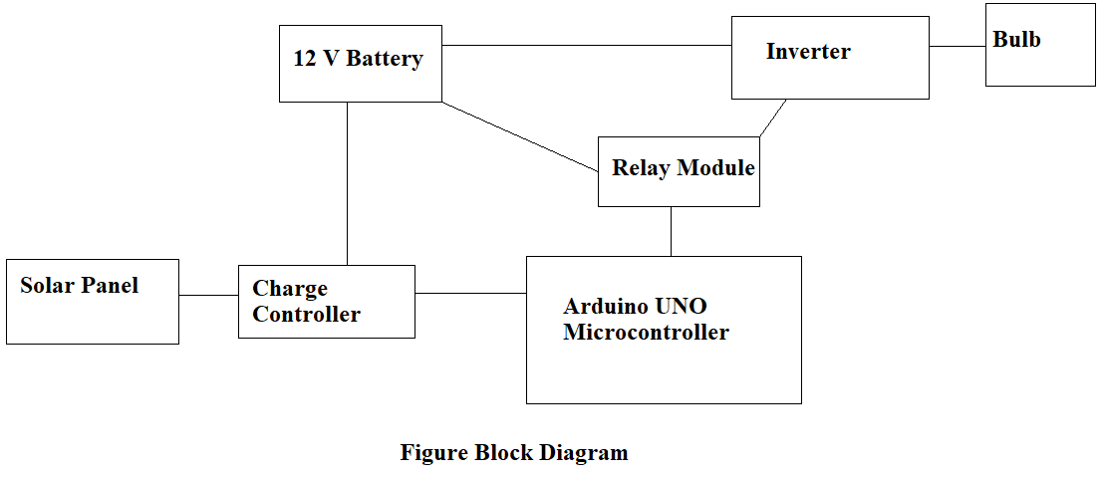



**CHAPTER 5: IMPLEMENTATION**



1. CHAPTER 5: DESIGN AND IMPLEMENTATION

This chapter will cover the design and implementation of the project. The implementaion phase combines the design phase outputs, requirements and the technology for usage.

* 1. DESIGN PHASE

Designing phase can be explanied by connecting every part of the system together. The solar panel, arduino chip, inverter, charge controller, bulb and battery.

The solar panel will get the solar energy and it will use that solar power to charge the battery with the help of charge controller. Then the inverter will convert that 12 V DC to 120-150 V AC. The system will of course does that with the help of arduino chip.

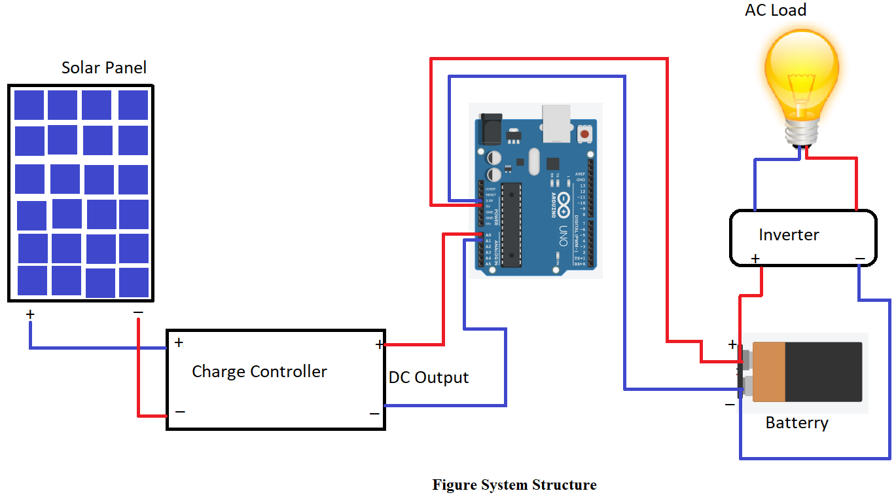

* 1. BUILDING THE HARDWARE

It took me more than two months to gather the materials and components fort he system. Because I couldn’t find all the parts of the system in just one place. That is why I visited a lot of electronic shops in order to find all the necessary parts that I need for the system design. After gathering all the components for the system I started the building the circuit of the system. Here is the list of every hardware component that I used in the project:

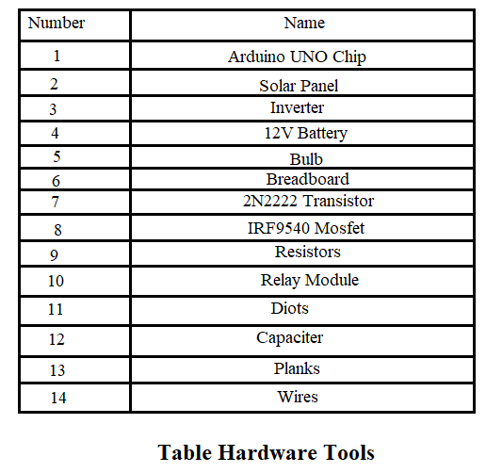

* 1. BUILDING THE SOFTWARE

After I gathered the hardware materials, I started to software part of the project. I started building the sofware part on Arduino IDE software. Of course my priority was the hardware part of the project but I simultaneously developed the hardware and software part of the project. The sofware part was not easy for me at first. However when I did some researches I saw that developing the software part was not that difficult and developed it with minor problems. After the tests I did I also solved that minor problems on the software part.

* 1. IMPLEMENTATION PHASE

After the development of both hardware and software part of the project I combined them in implementation phase. Firstly, I started building the hardware part of the project and simultaneously I developed the sofware part. After finishing the development of both hardware and sofware part I combined the hardware and software part together.

* 1. REAL DESIGN OF THE PROJECT

I took the picture of the real design of the project from various angles to show all the details about the design of the project.

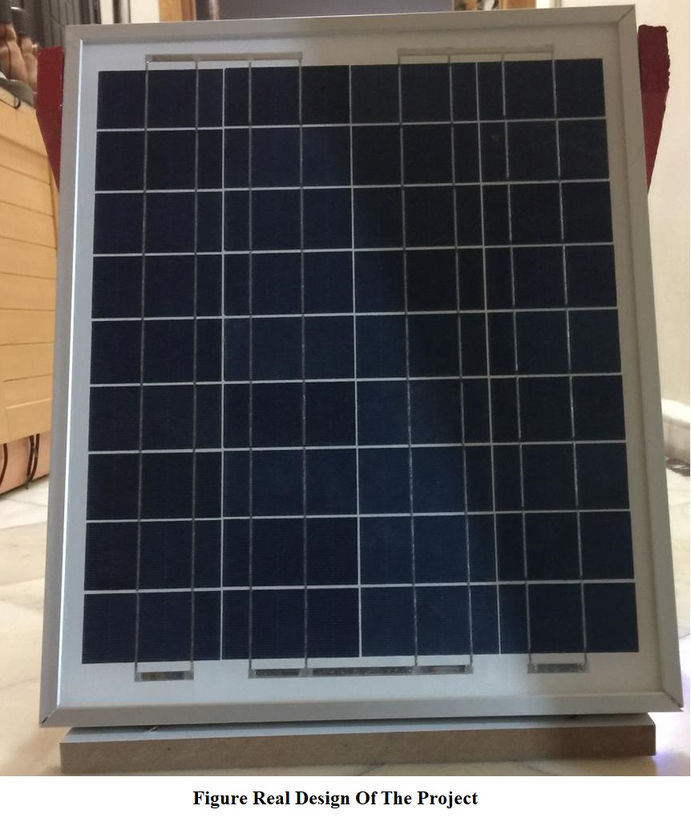

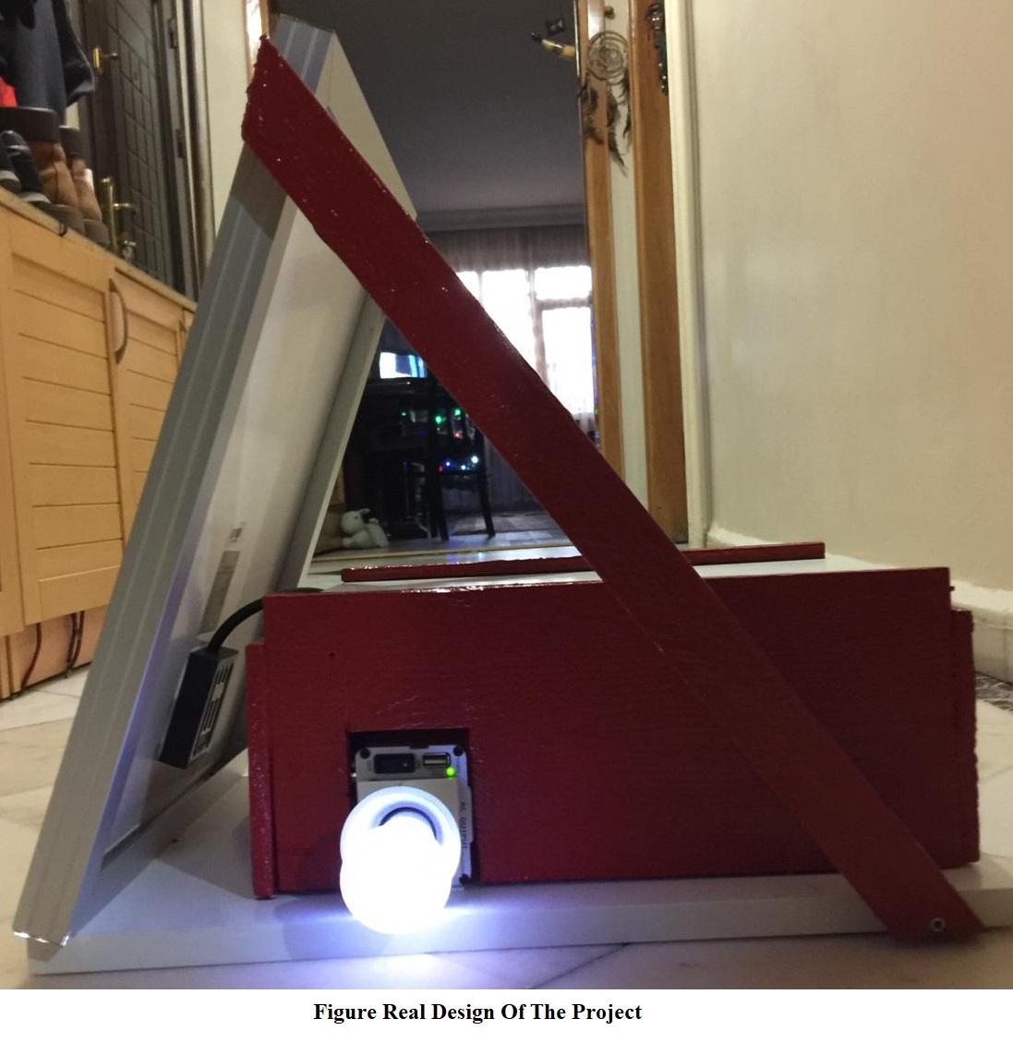

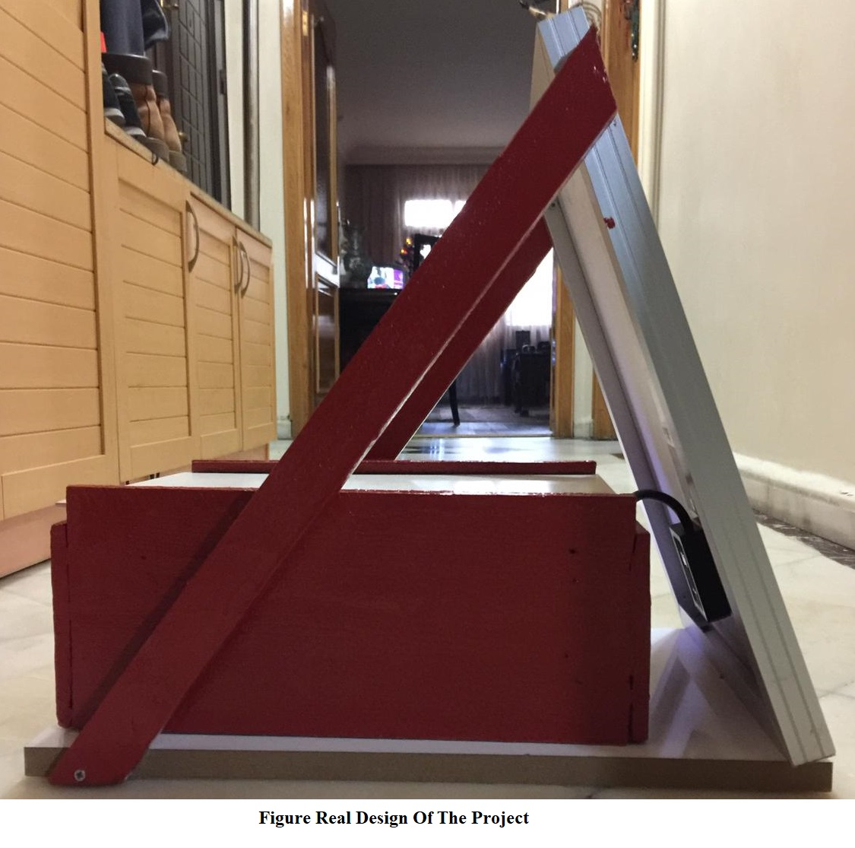

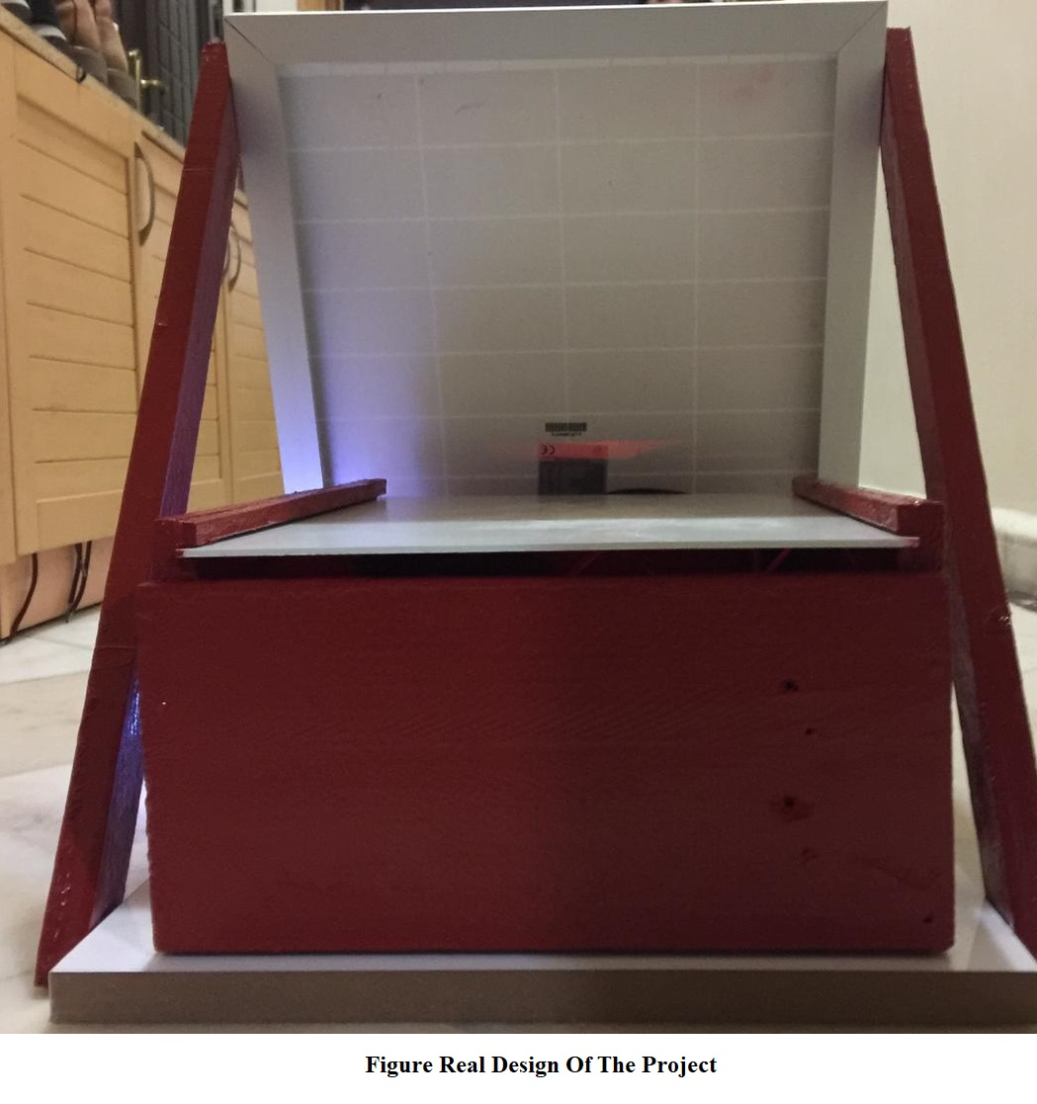

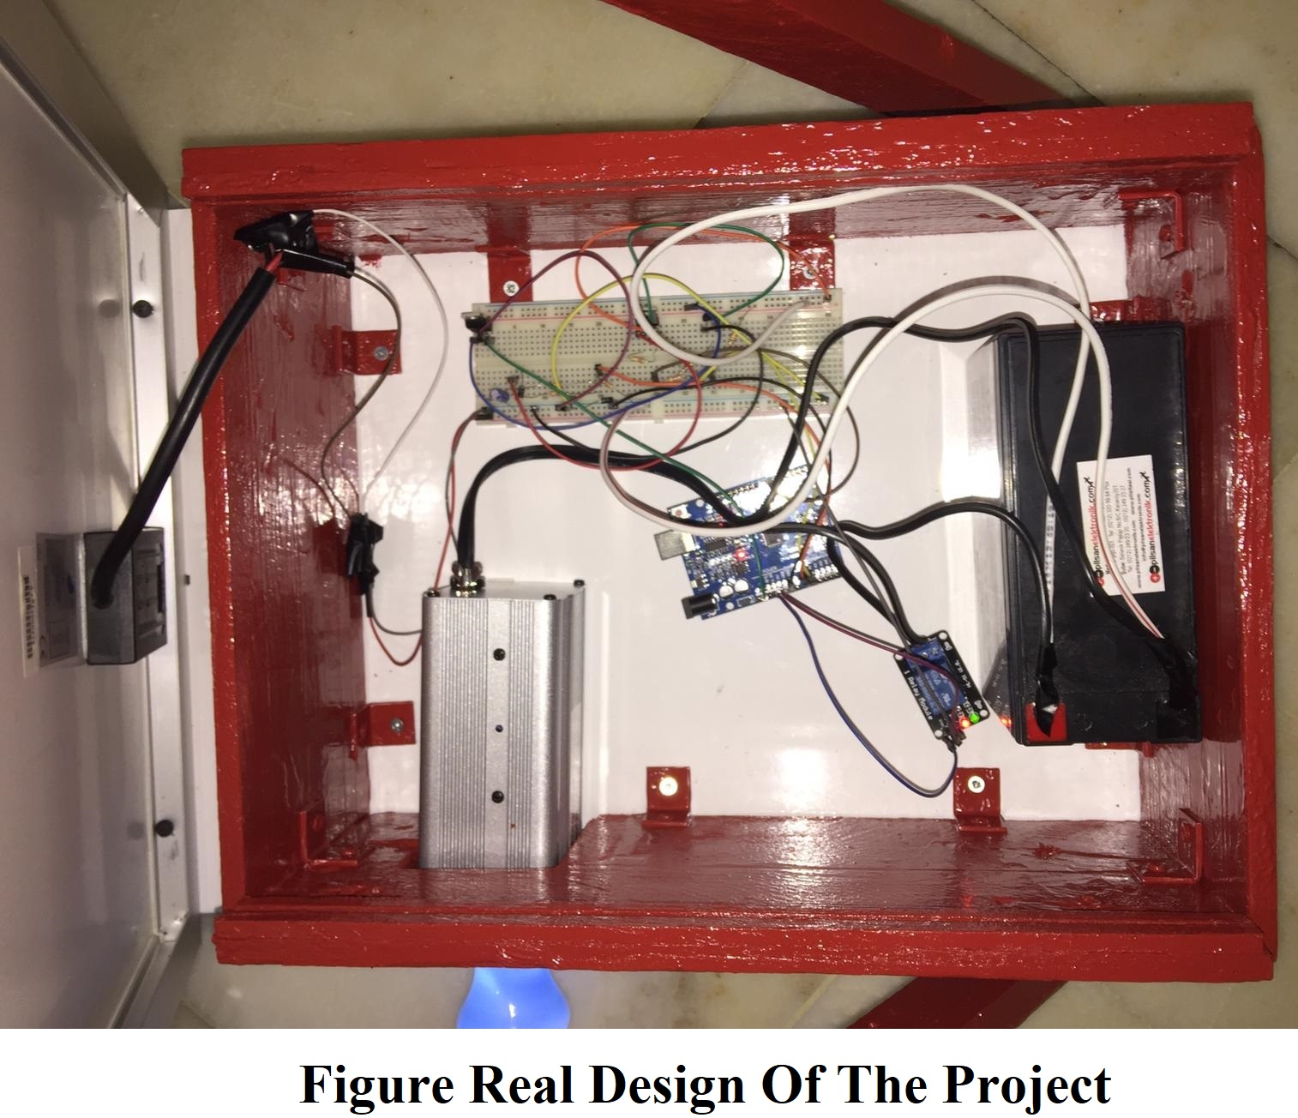



**CHAPTER 6: TESTING AND TOOLS**



1. CHAPTER 6: TESTING AND TOOLS

This chapter will contain the last phase of this project, which is testing and tools. In the testing part, performance and functionality testings were performed.

* 1. TESTING

Two types of testing was done to test the Solar UPS Project. These tests were performance and functionality testing.

* 1. PERFORMANCE TESTING

After constructing all the parts together of the project and developing the software part using Arduino IDE, I had some critical problems about the hardware part of the project. The wires which were connected to the battery melted due to the problem that they touched each other. This major problem resulted in these two wires to melt. I solved this problem by using stronger and more sheltered wires. Also I tried my best to maket hem not touch each other. With that I solved a critical problem.

* 1. FUNCTIONALITY TESTING

After solving the wire problem, I didn’t have any functional problems with the project. I tested this by using Arduino IDE Sofware and with a multimeter but the project worked as I wanted it to work.

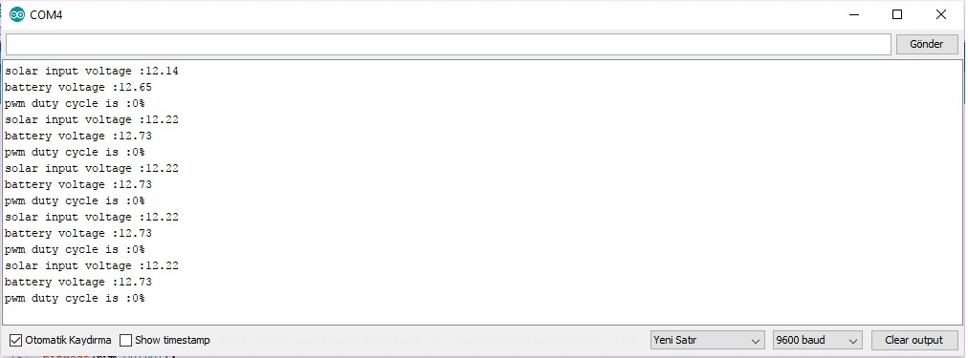

As we can see that when the system is not under the sun, pwm duty cycle is 0%. This means the battery is not charging as expected.

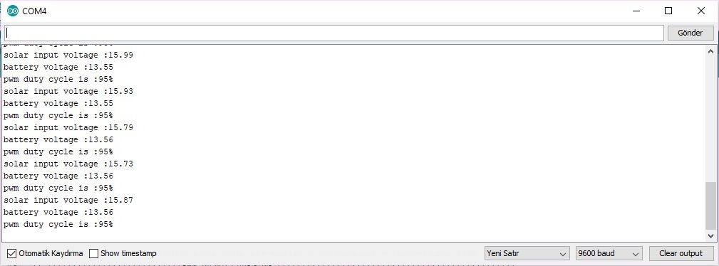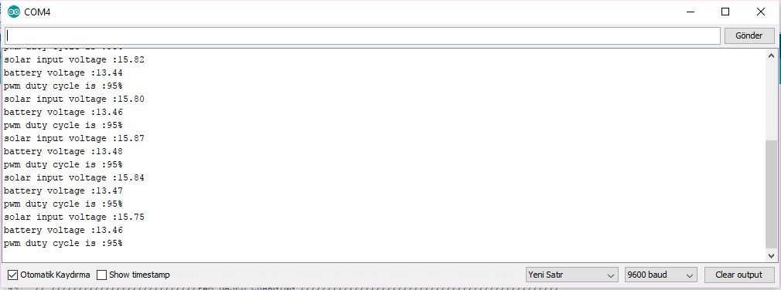

As we can see here that when the system is under the sun, pwm duty cycle is 95% which means the battery is charging and the system is working properly. I tested this two separate days just to be sure.

* 1. TOOLS AND TECHNIQUES

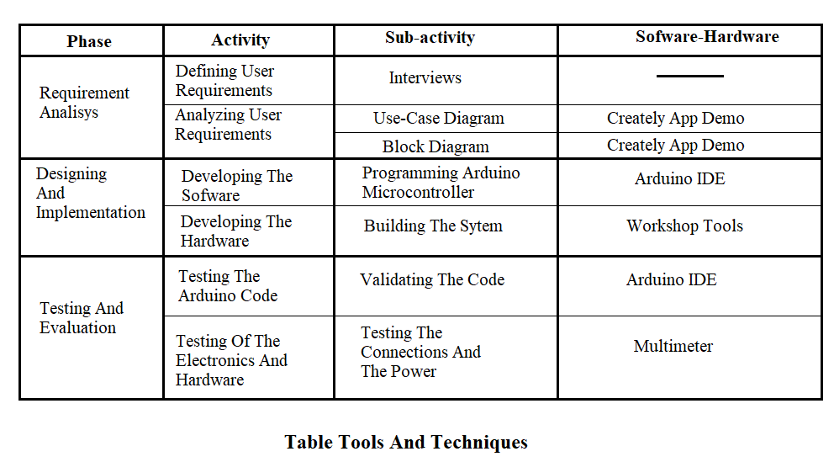

* 1. MAINTANCE

This is the final stage of this project. At this stage, maintaining, updating and enhancing the system will take place, which contains all the problems and errors that are met through the usage of the completed system which resulted in a updated and enchanced system.

I am maintaining both the hardware and the sofware components because if something changes in hardware I must change the sofware as well. So I linked all the components together and if anything changes even if it is a simple change, the whole system will be affected. This can lead the need of experience to maintain the components whenever something changes.

* 1. CONCLUSION

In today’s World, with the improvement of the technological development, people have become more demanding in terms of quality of life. However, today the usage of renewable energy source is just 5%-6%. This is causing the World and the quality of people’s lives a lot of problem.

So, I decided to make a project which will use solar energy which is a renewable energy and help the World at least a little bit in terms of global warming. In terms of usefullnes I think my solar based UPS are very usefull because it saves a lot of energy and does not pollute the environment while provide us electric. Also it does not stop working even if there is cuts in power because it is a UPS.

However, this project can not do everything by itself. If people don’t charge the system properly the system won’t work. Finally, we people must be more sensitive about our lifestyle and use more renewable sources. If we don’t do that our World will be irrevocably damaged.

REFERENCES

* To test the circuits virtually. [www.tinkercad.com](http://www.tinkercad.com) (11.10.2018)
* To learn about solar charge controller. [www.electroschematics.com](http://www.electroschematics.com) (11.10.2018)
* To maket he diagrams. [www.creately.com](http://www.creately.com) (12.10.2018)
* To see how effectiveness works. [www.york.ac.uk](http://www.york.ac.uk) (14.10.2018)
* To learn what is effectiveness. [www.businessdictionary.com](http://www.businessdictionary.com) (18.10.2018)
* To learn about my requirements. [www.stackoverflow.com](http://www.stackoverflow.com) (05.11.2018)
* To learn what is interoperability. [www.techopedia.com](http://www.techopedia.com) (07.11.2018)
* To download and learn about arduino. [www.arduino.cc](http://www.arduino.cc) (12.11.2018)
* To see the synonyms of the english words. [www.thesaurus.com](http://www.thesaurus.com) (11.10.2018)
* To translate thurkish into english. translate.google.com (18.11.2018)
* To see how waterfall methodology works. [www.airbrake.io](http://www.airbrake.io) (18.11.2018)
* To search methodologies. [www.ukessays.com](http://www.ukessays.com) (20.11.2018)
* To search methodologies. [www.itinfo.am](http://www.itinfo.am) (20.11.2018)
* To search about how to develop software and methodologies. en.wikipedia.org (03.12.2018)
* To see different types of methodologies. [www.quora.com](http://www.quora.com) (03.12.2018)
* For programming methodology tutorial. [www.tutorialspoint.com](http://www.tutorialspoint.com) (03.12.2018)
* To make research about programming methodologies. [www.chegg.com](http://www.chegg.com) (07.12.2018)
* To make research about programming methodologies. see.stanford.edu (08.12.2018)
* To make research about computer methods. [www.sciencedirect.com](http://www.sciencedirect.com) (10.12.2018)
* To make research about inverters. [www.sunpower-uk.com](http://www.sunpower-uk.com) (11.12.2018)
* To learn how to convert 12V DC to 220V AC. [www.electronicshub.org](http://www.electronicshub.org) (11.12.2018)
* To learn how solar charge controllers work. [www.solar-electric.com](http://www.solar-electric.com) (16.12.2018)
* To learn about solar charge controllers. [www.victronenergy.com.tr](http://www.victronenergy.com.tr) (18.12.2018)
* To learn about solar energy and soalr panels. [www.chip.com.tr](http://www.chip.com.tr) (18.12.2018)
* To learn about solar panels. [www.gunesdukkan.com](http://www.gunesdukkan.com) (24.12.2018)
* To learn about solar panels. [www.mrsolar.com](http://www.mrsolar.com) (26.12.2018)
* To make research about solar power and solar panels. [www.enerjibes.com](http://www.enerjibes.com) (26.12.2018)
* To learn about how solar panels work. [www.ayetek.com](http://www.ayetek.com) (03.01.2019)
* To learn what are solar panels. <http://www.ayetek.com> (03.01.2019)
* To learn about solar panel and solar energy. <http://www.helpmewv.org> (03.01.2019)
* To learn about inverter circuits. upset.com.tr (03.01.2019)
* To learn about arduino. [www.robotiksistem.com](http://www.robotiksistem.com) (05.01.2019)
* To learn about inverter circiut with arduino. [www.makingcircuits.com](http://www.makingcircuits.com) (05.01.2019)
* To learn about where solar panels using platforms. maker.robotistan.com (05.01.2019)
* To learn about solar based UPS’s. [www.researchgate.net](http://www.researchgate.net) (06.01.2019)
* To learn about solar charge controller with arduino. [www.instructables.com](http://www.instructables.com) (06.01.2019)
* To learn about solar panel battery charge controller using arduino. <http://www.bristolwatch.com> (06.01.2019)
* To learn about solar UPS project. <http://nevonprojects.com> (06.01.2019)